Aim
To perform Data Manipulation Language (DML) operations such as INSERT, UPDATE, and DELETE on records in a Banking Database using MySQL Workbench.

Description
Data Manipulation Language (DML) commands are used to add, modify, and remove data stored in database tables. In a Banking Database, these commands help insert new customer or account records, update existing customer or transaction details, and delete unwanted or obsolete records while maintaining the database structure.

Procedure
- Open MySQL Workbench and connect to the MySQL Server.
- Select the Banking Database using the USE command.
- Use the INSERT command to add new records to the required banking table.
- Use the UPDATE command with an appropriate WHERE clause to modify existing records.
- Use the DELETE command with a WHERE clause to remove specific records from the table.
- Execute each command using the Execute (⚡) button or Ctrl + Shift + Enter.
- Verify the changes by executing the SELECT statement to view the updated records.

How to Run
- Launch MySQL Workbench.
- Connect to the MySQL Server.
- Open a New SQL Tab.
- Select the Banking Database.
- Enter the required DML command (INSERT, UPDATE, or DELETE).
- Execute the query by clicking the Execute (⚡) button or pressing Ctrl + Shift + Enter.
- Verify the successful execution by checking the Action Output panel and displaying the table data using the SELECT statement.

DML Commands Covered
- INSERT – Adds new records to a table.
- UPDATE – Modifies existing records in a table.
- DELETE – Removes one or more records from a table based on a specified condition.
This format is suitable for a DBMS laboratory record covering the DML commands in a banking database.

QUERY 1 INSERT

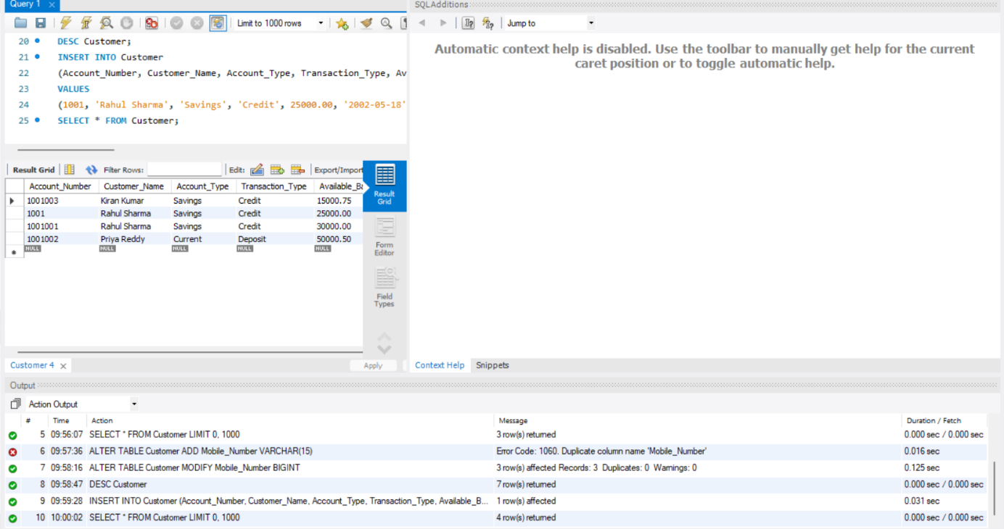

QUERY 2 UPDATE

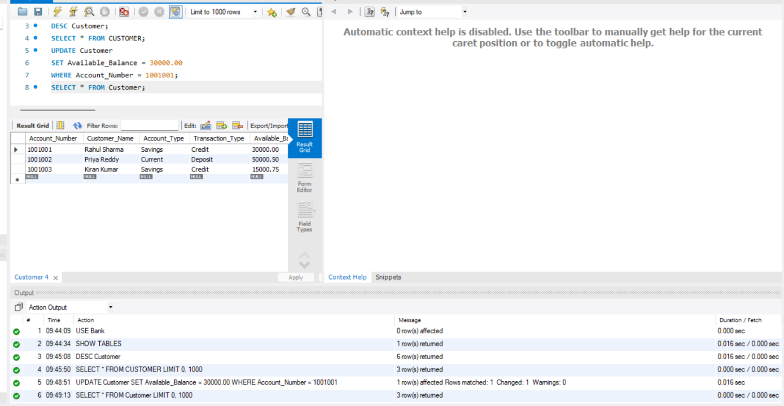

QUERY 3 DELETE

